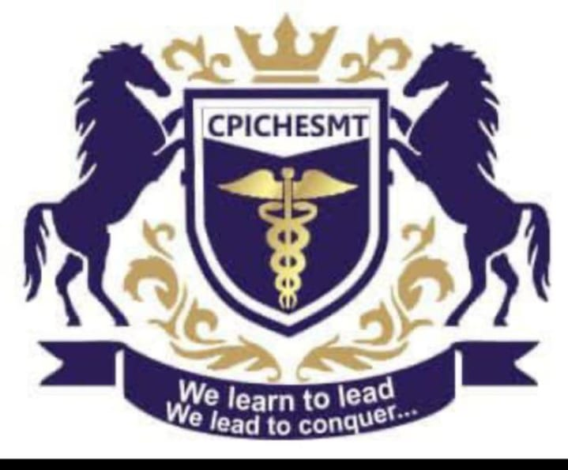

CROWN POINT INTERNATIONAL COLLEGE OF HEALTH SCIENCES, MANAGEMENT AND TECHNOLOGY

**FIRST SEMESTER ACADEMIC COLLEGE CALENDER FOR 2025/2026 ACADEMIC SESSION**

|  |  |  |
| --- | --- | --- |
| **Activities** | **Dates** | **Facilitators** |
| **Resumption Dates** | **Monday, 15th Sept., 2025** |  |
| **Physical Registration Begins and Ends** | **Tuesday, 16th Sept. – Wed., 17th September, 2025** |  |
| **Staff Retreat** | **Thur., 18th – Friday, 19th 2025** | **Dr. Samuel T. Ojong** |
| **Skeleton Lecture Begins** | **Monday, 22nd Sept., 2025** |  |
| **Independent Day (Road Work)** | **1st October, 2025** | **Mr. Ogunleye Olayinka / Mr. Joseph Awo** |
| **Breast Cancers Awareness Month /**  **World Breast Feeding Week** | **October of Every Year** | **Miss Omodasola Ajigbotosho** |
| **Orientation Week** | **Monday, 29th Sept. – Friday, 3rd October, 2025** |  |
| **Full Lectures Begin** | **6th October, 2025** |  |
| **World Teachers’ Day** | **5th October, 2025** | **Dr. Adekunle Ajasa** |
| **World Mental Health Day** | **10th October, 2025** | **Mr. Alao Kamarudeen** |
| **International Day of the Girl Child** | **11th October, 2025** | **Phar. Margret T. Ojong** |
| **Clinical Presentation Begins and Ends** | **Monday 13th – 17 Oct., 2025** |  |
| **Global Hands Washing Day** | **15th October, 2025** | **Mr. Kenneth M. Ojong** |
| **First Assessment Test** | **Mon. 20th – Fri. 24th Oct., 2025** |  |
| **United Nation’s Day** | **24th October, 2025** | **Dr. Samuel T. Ojong** |
| **World Polio Malthus Day** | **24th October, 2025** | **Mr. Kenneth M. Ojong** |
| **Students Week (Pageantry, Rag Day, Cultural Day, Jean Carnival, Old School, Sports Activities)** | **Monday, 27th October – Friday, 31st October, 2025** | **S.R.C. President with his Executive Members** |
| **Freshers’ Night** | **31st October, 2025** | **Mr. Ogunleye Olayinka / Phar. Margret T. Ojong** |
| **World Diabetes Day** | **14th November, 2025** | **Phar. Paul Sekna’an** |
| **World AIDS Day** | **1st December, 2025** | **Phar. Paul Sekna’an** |
| **College Charity Day** | **5th December, 2025** | **Dr. Samuel T. Ojong** |
| **Departmental Presentation Week** | **Monday, 15st December – Friday, 19th December, 2025** |  |
| **Christmas Carrole & Staff and Students Awards** | **Friday, 19th December, 2025** | **Dr. Samuel T. Ojong** |
| **1st Semester Examination Commencement and End** | **Monday, 26th January – Friday, 6th February, 2026** | **Mr. Jimmy Adeomi / Mr. Joseph Owor** |
| **End of Late Registration / Matriculation** | **31st October, 2025** |  |
| **Result Compilation and Submission** |  | **Mr. Simeon Nsikka / Mr. Joseph Owor** |
| **End of Semester Activity** |  |  |
| **Approval of First Semester Result** |  | **Phar. Margret T. Ojong** |

**NOTE: This is a Tentative Time Tabl. It is subjected to review and the approval of the academic board of the college.**

**REGISTRAR**